“I think this is a great idea. I live a bit north, however, so wouldn't be able to use it as often as those closer to the park. Thanks!”

Q1: How did you learn about the ArtsPark?

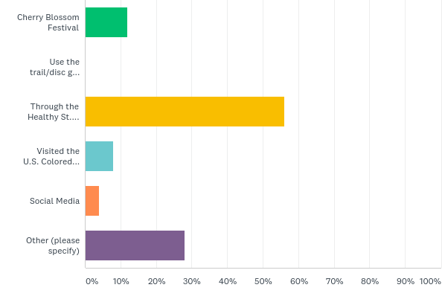
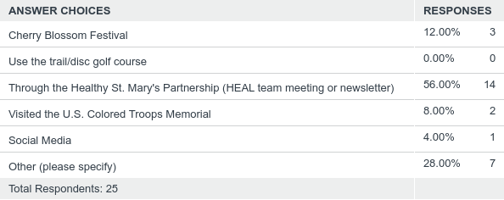

Other Responses Include:
Friend, Walk with Ease Program, Community Development Corporation

“Marvelous idea, great opportunity to have a well-used facility in the Lexington Park area!”

Q2: What would you like to have in the park? (Please check all that apply)

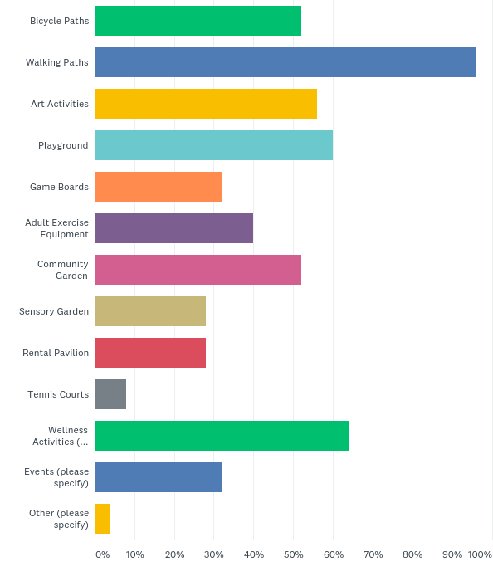
Other Responses Include:
Music/Performing Arts events, Festivals, Arts & Crafts Events, Nature Events, Outdoor Movies, Space for Food Vendors

“I am not sure what an artspark is. Based on the survey questions I am not sure how it is different from any other park in the area.”

Q3: How often would you visit a Lexington Park ArtsPark with the amenities you listed?

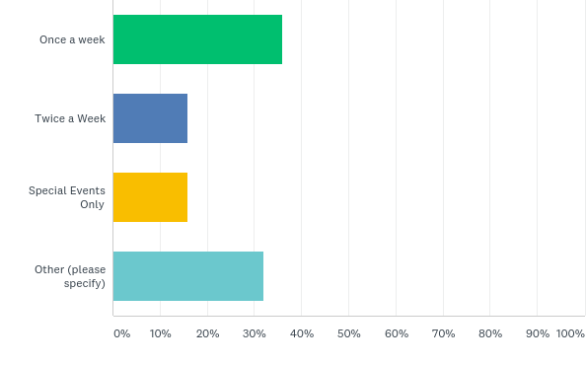
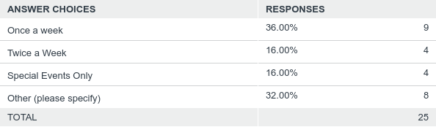

Other Responses Include:
A few times per month, Once per month, A few times a year

